Mathematical Optimization Terminology
A Comprehensive Glossary of Terms
- Discusses real-world applications of optimization and how it can be used in algorithms  - Explains the essential formulations of optimization in mathematics  - Covers a more practical approach to optimization  Mathematical Optimization Technology: A Comprehensive Glossary of Terms is a practical book with the essential formulations, illustrative examples, real-world applications, and main references. This book helps readers gain a more practical understanding of optimization and can then apply it to their own studies. This book also addresses the need for a practical publication that introduces these concepts and techniques. This book is introductory but not elementary. | 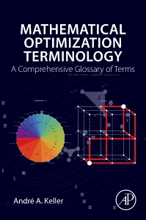  By Andre A. Keller  Published November  2017  326 pages  Paperback  978-0-12-805166-5  Price:  USD $150.00  GBP £118.00  EUR €138.00  AUD $160.86
For more information, including Table of Contents
http://www.elsevierdirect.com/9780128051665

